Ex 6

Step 1: Download and install Java
Hadoop is built on Java, so users must have Java installed on your PC. You can get the most recent version of Java from the official website. After downloading, follow the installation wizard to install Java on your system.
JDK: https://www.oracle.com/java/technologies/javase-downloads.html
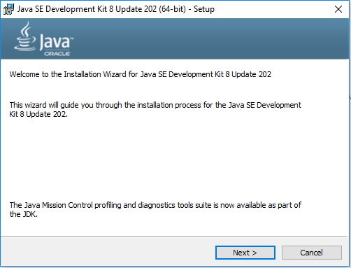
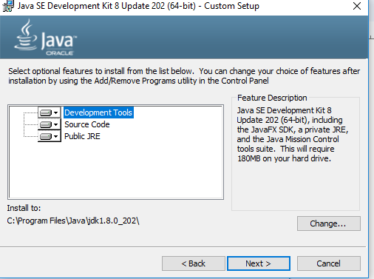
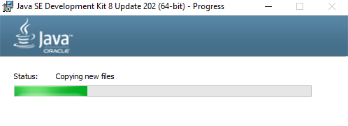
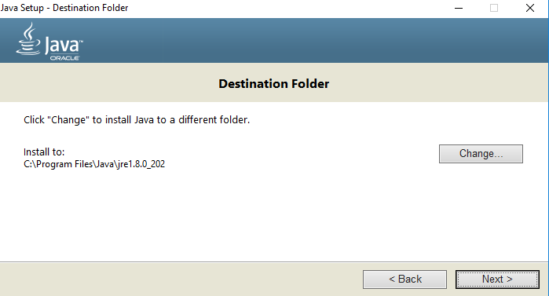
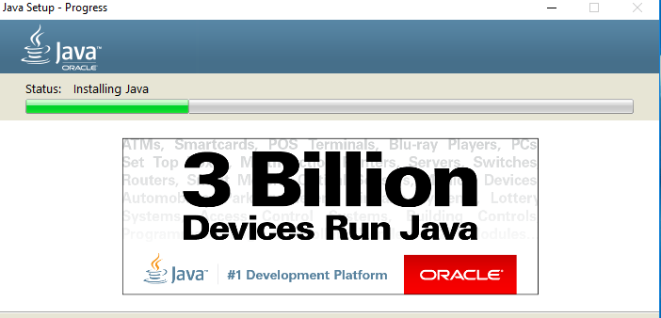
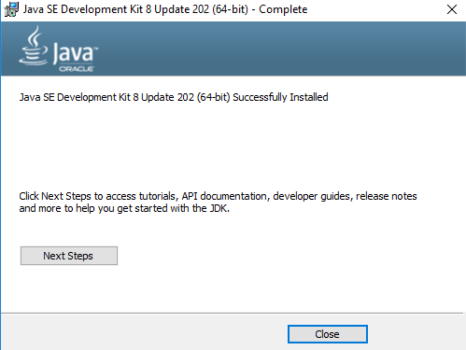
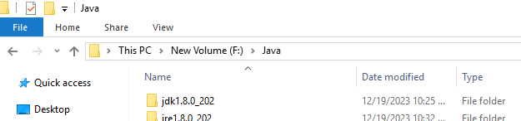

Step 2: Download Hadoop 3.2.4
Hadoop can be downloaded from the Apache Hadoop website. Make sure to have the latest stable release of Hadoop. Once downloaded, extract the contents to a convenient location.
Hadoop: https://hadoop.apache.org/releases.html

Step 3: Set Environment Variables
You must configure environment variables after downloading and unpacking Hadoop. Launch the Start menu, type “Edit the system environment variables,” and select the result. This will launch the System Properties dialogue box. Click on “Environment Variables” button to open.
Click “New” under System Variables to add a new variable. Enter the variable name “HADOOP_HOME” and the path to the Hadoop folder as the variable value. Then press “OK.”
Then, under System Variables, locate the “Path” variable and click “Edit.” Click “New” in the Edit Environment Variable window and enter “%HADOOP_HOME%bin” as the variable value. To close all the windows, use the “OK” button.

Step 4: Setup Hadoop
You must configure Hadoop in this phase by modifying several configuration files. Navigate to the “etc/hadoop” folder in the Hadoop folder. You must make changes to three files:
- core-site.xml
- hdfs-site.xml
- mapred-site.xml
Open each file in a text editor and edit the following properties:

In core-site.xml
<configuration>
<property>
<name>fs.default.name</name>
<value>hdfs://localhost:9000</value>
</property>
</configuration>

In hdfs-site.xml
<configuration>
<property>
<name>dfs.replication</name>
<value>1</value>
</property>
<property>
<name>dfs.namenode.name.dir</name>
<value>file:/hadoop-3.3.1/data/namenode</value>
</property>
<property>
<name>dfs.datanode.data.dir</name>
<value>file:/hadoop-3.3.1/data/datanode</value>
</property>
</configuration>

In mapred-site.xml
<configuration>
<property>
<name>mapred.job.tracker</name>
<value>localhost:54311</value>
</property>
</configuration>

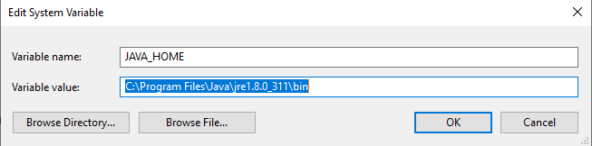
Ex 6
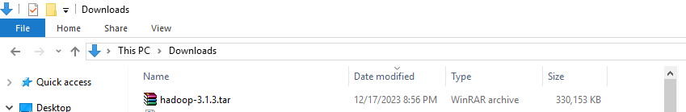
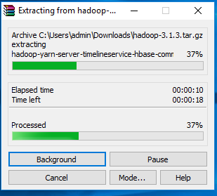
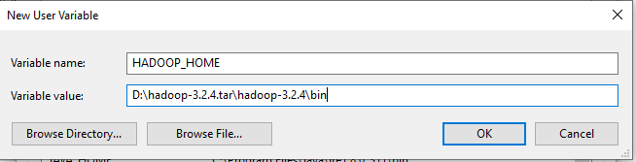
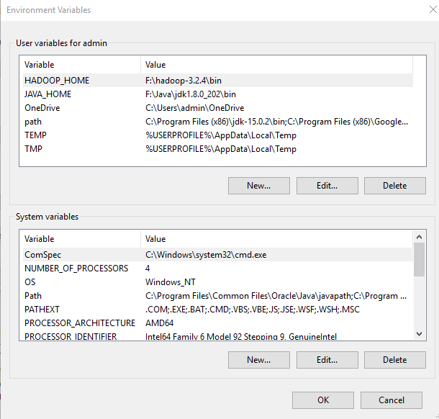
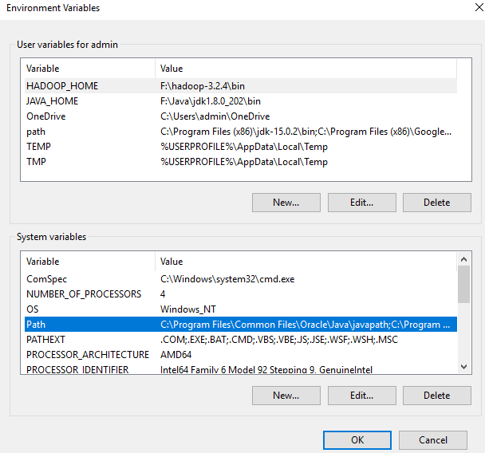
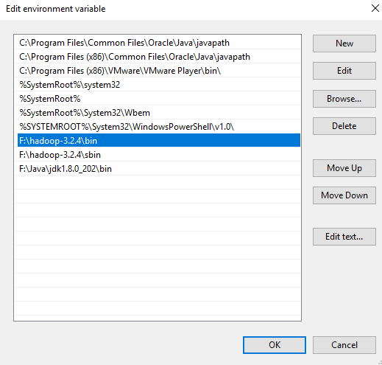

Creating Folders
We need to create a folder data in the hadoop directory, and 2 sub folders namenode and datanode.
Create DATA folder in the Hadoop directory

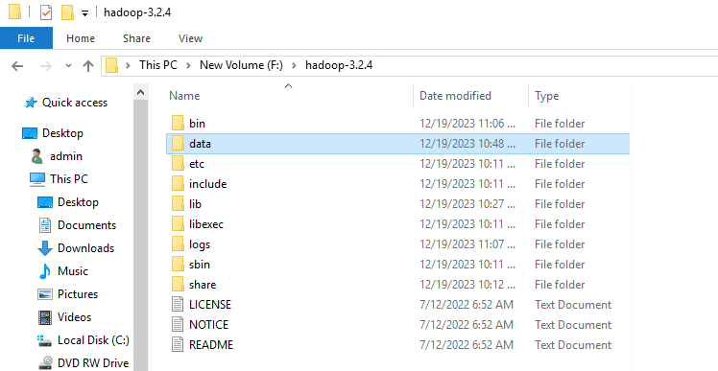
- Once DATA folder is created, we need to create 2 new folders namely, namenode and datanode inside the data folder
- These folders are important because files on HDFS reside inside the datanode.
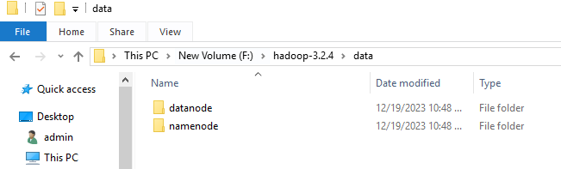
Editing Configuration Files
Now we need to edit the following config files in hadoop for configuring it :-
(We can find these files in Hadoop -> etc -> hadoop)
* core-site.xml
* hdfs-site.xml
* mapred-site.xml
* yarn-site.xml
* hadoop-env.cmd

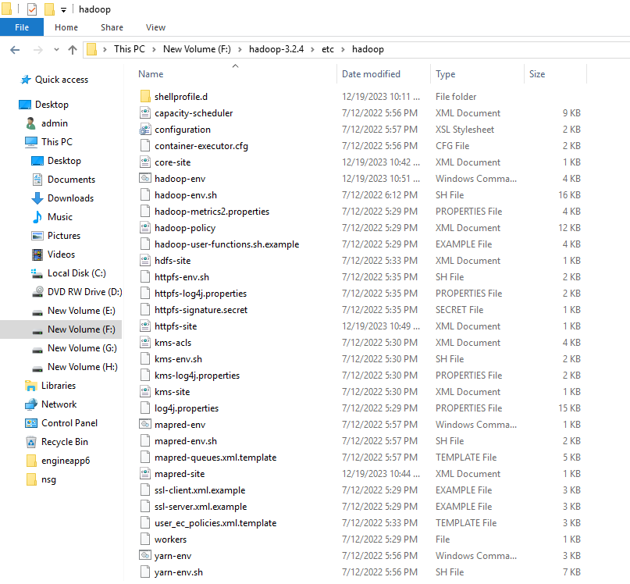
Editing core-site.xml
Right click on the file, select edit and paste the following content within <configuration> </configuration> tags.
<configuration>
<property>
<name>fs.defaultFS</name>
<value>hdfs://localhost:9000</value>
</property>
</configuration>

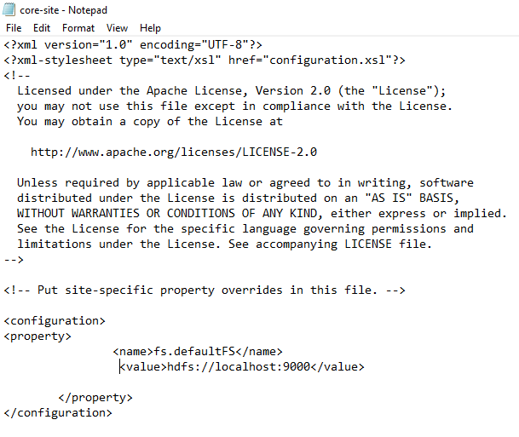

Editing hdfs-site.xml
Right click on the file, select edit and paste the following content within <configuration></configuration>tags.
<configuration>
<property>
<name>dfs.replication</name>
<value>1</value>
</property>
<property>
<name>dfs.namenode.name.dir</name>
<value>F:\hadoop-3.2.4\data\namenode</value>
<final>true</final>
</property>
<property>
<name>dfs.datanode.data.dir</name>
<value>F:\hadoop-3.2.4\data\datanode</value>
<final>true</final>
</property>
</configuration>
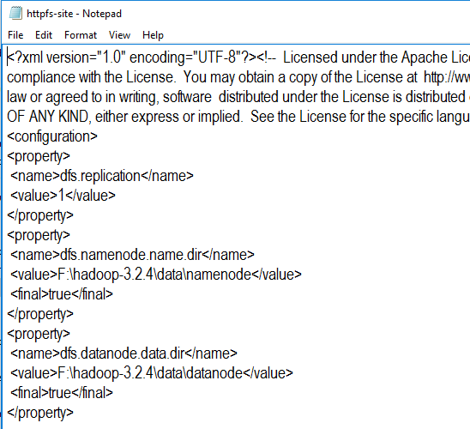
Editing mapred-site.xml
Right click on the file, select edit and paste the following content within <configuration> </configuration> tags.
<configuration>
<property>
<name>mapreduce.framework.name</name>
<value>yarn</value>
</property>
</configuration>
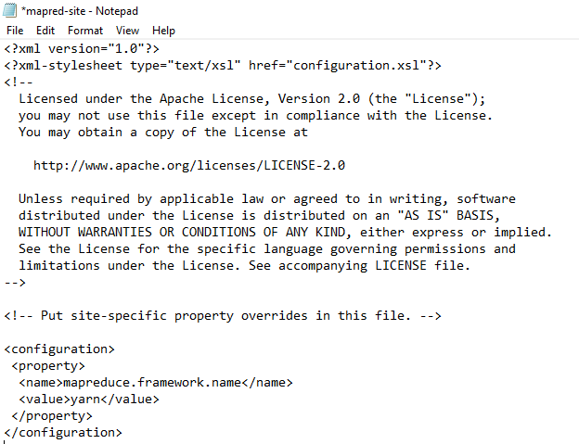

Editing yarn-site.xml
Right click on the file, select edit and paste the following content within <configuration> </configuration> tags.
<configuration>
<property>
<name>yarn.nodemanager.aux-services</name>
<value>mapreduce_shuffle</value>
</property>
<property>
<name>yarn.nodemanager.auxservices.mapreduce.shuffle.class</name>
<value>org.apache.hadoop.mapred.ShuffleHandler</value>
</property>
<!-- Site specific YARN configuration properties →
</configuration>
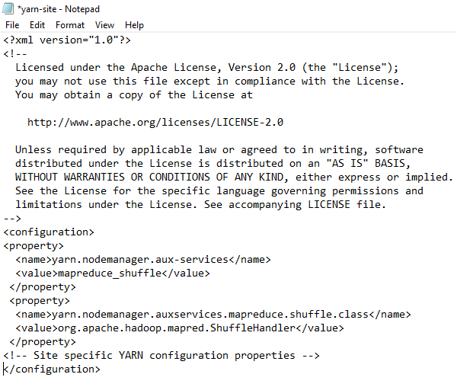
Verifying hadoop-env.cmd
Right click on the file, select edit and check if the JAVA_HOME is set correctly or not. We can replace the JAVA_HOME variable in the file with your actual JAVA_HOME that we configured in the System Variable.

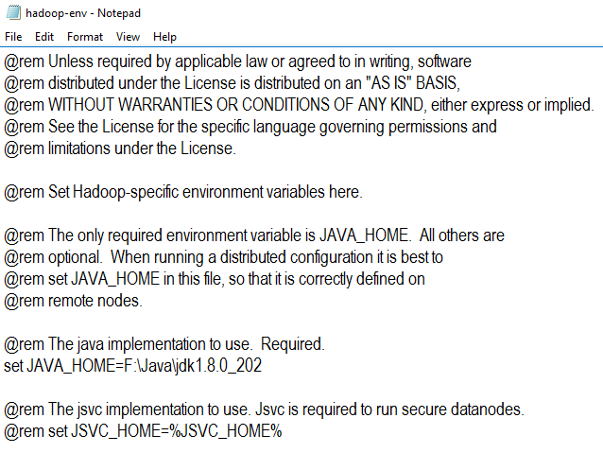
Configuration files
Download from
https://drive.google.com/file/d/1zuT8G3D2JFkbkdv6fMhnhBOj8YSsgJc-/view
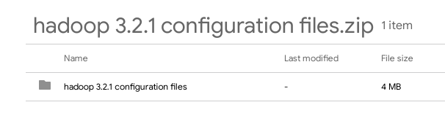
Replace old bin with new bin
